Interior Region
# Source: AI Source: Provided by: [Data Path: Persons Table -> ID Column: 1, Name_En Column: Motasem Essam] -> From: [ChatGPT] on [7/25/2026]
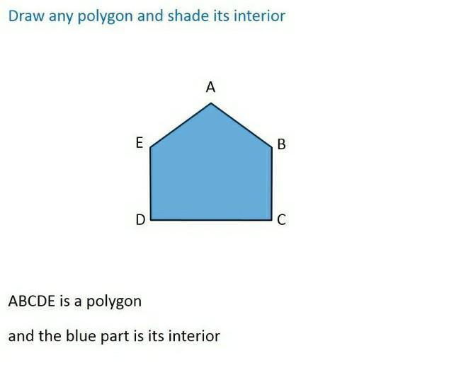
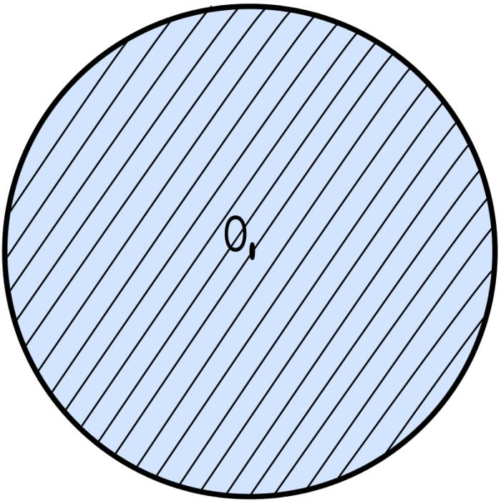
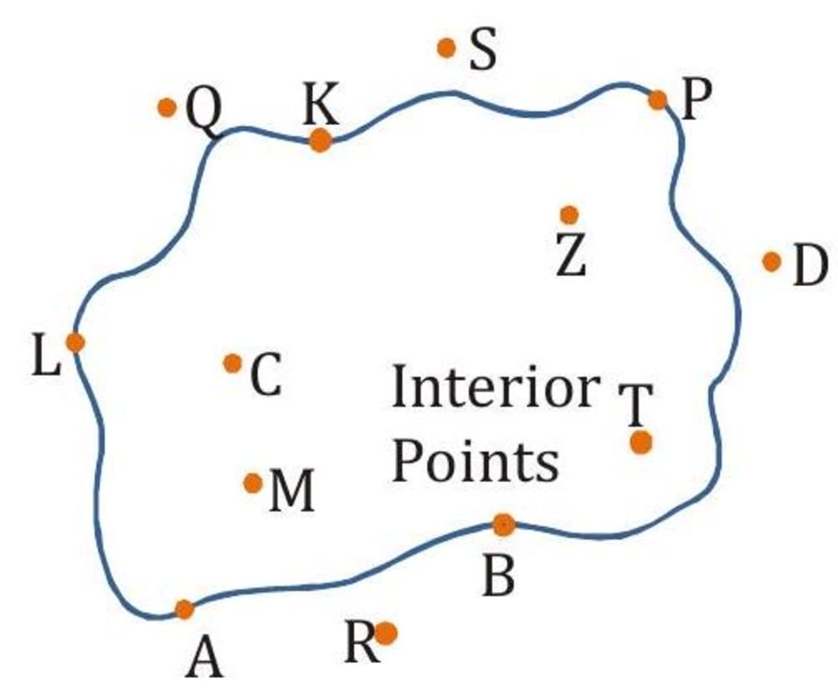
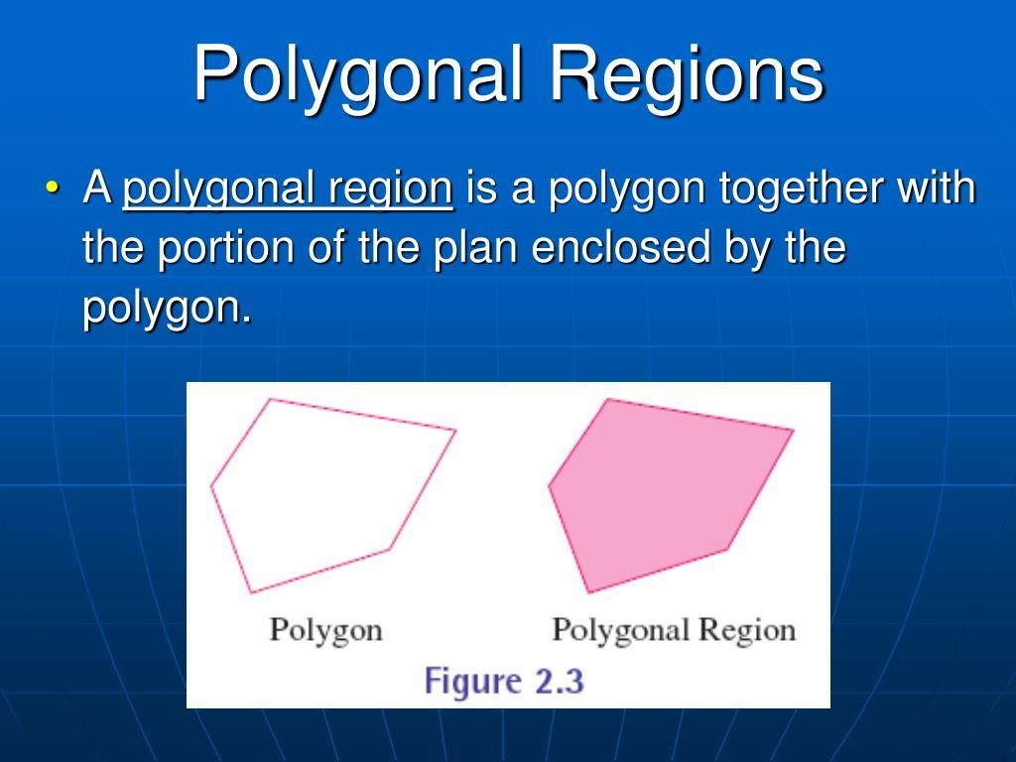
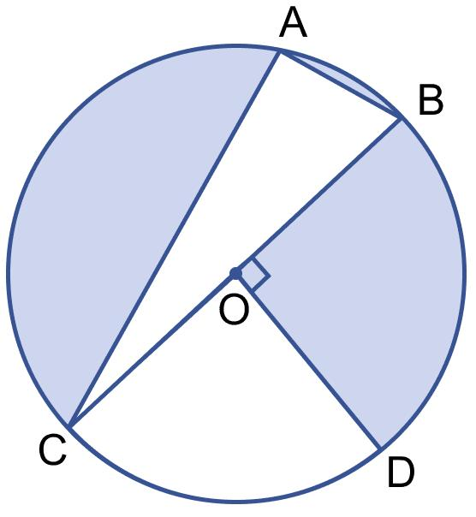

Definition
# Source: AI Source: Provided by: [Data Path: Persons Table -> ID Column: 1, Name_En Column: Motasem Essam] -> From: [ChatGPT] on [7/25/2026]
An Interior Region is the set of all points that lie strictly inside a closed geometric figure, excluding its boundary unless otherwise specified.
The interior region represents the enclosed portion of a figure such as a polygon, circle, or ellipse. Every interior point is completely surrounded by the boundary and does not lie on the edge.

Characteristics
# Source: AI Source: Provided by: [Data Path: Persons Table -> ID Column: 1, Name_En Column: Motasem Essam] -> From: [ChatGPT] on [7/25/2026]
An interior region:
- Lies completely inside a closed figure.
- Is enclosed by a boundary.
- Does not include the boundary in the strict mathematical definition.
- Contains infinitely many points.
- Has a finite area if the enclosing figure is bounded.
- Is separated from the exterior by the boundary.

Illustration

Interior of a Rectangle
# Source: AI Source: Provided by: [Data Path: Persons Table -> ID Column: 1, Name_En Column: Motasem Essam] -> From: [ChatGPT] on [7/25/2026]
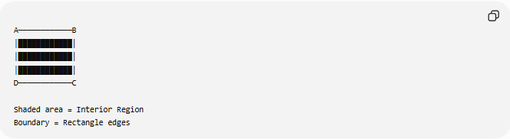
A────────────B
│████████████│
│████████████│
│████████████│
D────────────C

Shaded area = Interior Region
Boundary = Rectangle edges
The shaded area represents the interior region.

Interior of a Circle
# Source: AI Source: Provided by: [Data Path: Persons Table -> ID Column: 1, Name_En Column: Motasem Essam] -> From: [ChatGPT] on [7/25/2026]
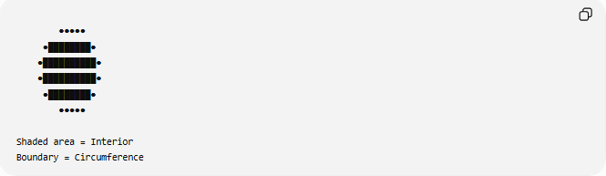
●●●●●
●████████●
●██████████●
●██████████●
●████████●
●●●●●

Shaded area = Interior
Boundary = Circumference

Mathematical Representation
# Source: AI Source: Provided by: [Data Path: Persons Table -> ID Column: 1, Name_En Column: Motasem Essam] -> From: [ChatGPT] on [7/25/2026]
Suppose a region is enclosed by the boundary:
$$∂R$$
The interior is commonly written as:
$$\operatorname{Int}\left(R\right)$$
or
$$R^{∘}$$
(read as "the interior of $R$").

Example
For a circle:
Interior:
$$x^{2}+y^{2}<r^{2}$$
Boundary:
$$x^{2}+y^{2}=r^{2}$$
The interior excludes the circumference.

Examples
# Source: AI Source: Provided by: [Data Path: Persons Table -> ID Column: 1, Name_En Column: Motasem Essam] -> From: [ChatGPT] on [7/25/2026]
Example 1 – Triangle
The region inside the three sides of the triangle is the interior region.
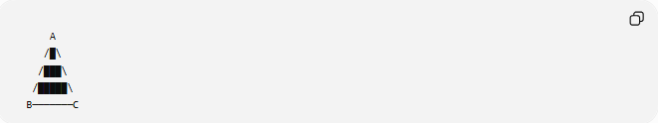
A
/█\
/███\
/█████\
B───────C

Example 2 – Rectangle
The area enclosed by the four sides is the interior region.

Example 3 – Circle
Every point satisfying
$$x^{2}+y^{2}<r^{2}$$
belongs to the interior region.

Interior Region vs Boundary
# Source: AI Source: Provided by: [Data Path: Persons Table -> ID Column: 1, Name_En Column: Motasem Essam] -> From: [ChatGPT] on [7/25/2026]
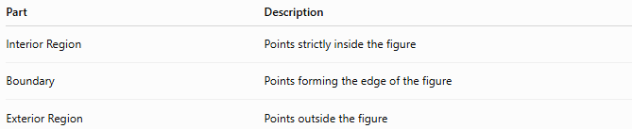
Part | Description
Interior Region | Points strictly inside the figure
Boundary | Points forming the edge of the figure
Exterior Region | Points outside the figure

Interior Region and Area
# Source: AI Source: Provided by: [Data Path: Persons Table -> ID Column: 1, Name_En Column: Motasem Essam] -> From: [ChatGPT] on [7/25/2026]
The interior region is the part used when computing area.
Examples:
Rectangle:
$$A=l×w$$
Triangle:
$$A=\frac{12}{b}h$$
Circle:
$$A=πr^{2}$$

Real-World Examples
# Source: AI Source: Provided by: [Data Path: Persons Table -> ID Column: 1, Name_En Column: Motasem Essam] -> From: [ChatGPT] on [7/25/2026]
Interior regions include:
- The inside of a room.
- The surface inside a swimming pool.
- The playing area of a football field.
- The interior of a fenced garden.
- The inside of a circular park.
- A country's land enclosed by its borders.

Applications
# Source: AI Source: Provided by: [Data Path: Persons Table -> ID Column: 1, Name_En Column: Motasem Essam] -> From: [ChatGPT] on [7/25/2026]
Interior regions are used in:
- Plane Geometry
- Coordinate Geometry
- Analytic Geometry
- Topology
- Engineering
- Architecture
- Surveying
- GIS (Geographic Information Systems)
- CAD (Computer-Aided Design)
- Computer Graphics

Advantages
# Source: AI Source: Provided by: [Data Path: Persons Table -> ID Column: 1, Name_En Column: Motasem Essam] -> From: [ChatGPT] on [7/25/2026]
Studying interior regions helps to:
- Compute areas.
- Identify enclosed spaces.
- Analyze geometric figures.
- Solve optimization problems.
- Model real-world objects.

Limitations
# Source: AI Source: Provided by: [Data Path: Persons Table -> ID Column: 1, Name_En Column: Motasem Essam] -> From: [ChatGPT] on [7/25/2026]
An interior region:
- Exists only for figures with boundaries.
- Does not include the boundary under the strict mathematical definition.
- Cannot exist without an enclosing figure.

Comparison with Related Concepts
# Source: AI Source: Provided by: [Data Path: Persons Table -> ID Column: 1, Name_En Column: Motasem Essam] -> From: [ChatGPT] on [7/25/2026]
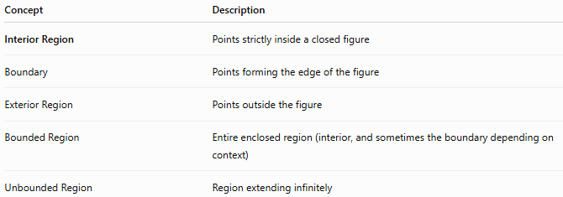
Concept | Description
Interior Region | Points strictly inside a closed figure
Boundary | Points forming the edge of the figure
Exterior Region | Points outside the figure
Bounded Region | Entire enclosed region (interior, and sometimes the boundary depending on context)
Unbounded Region | Region extending infinitely

Key Points
# Source: AI Source: Provided by: [Data Path: Persons Table -> ID Column: 1, Name_En Column: Motasem Essam] -> From: [ChatGPT] on [7/25/2026]
- An Interior Region consists of all points strictly inside a closed figure.
- It is enclosed by a boundary.
- The strict definition excludes the boundary.
- Interior regions have measurable area.
- They are fundamental in geometry and topology.

Conclusion
# Source: AI Source: Provided by: [Data Path: Persons Table -> ID Column: 1, Name_En Column: Motasem Essam] -> From: [ChatGPT] on [7/25/2026]
An Interior Region is the collection of all points located strictly inside a closed geometric figure, bounded by its edges or curves. It forms the enclosed portion of shapes such as polygons and circles and is the region used when calculating area. Interior regions are fundamental in plane geometry, coordinate geometry, analytic geometry, topology, engineering, architecture, surveying, GIS, CAD, and computer graphics, where they are used to define enclosed spaces, analyze shapes, and model two-dimensional objects.

